# High Level Concept

**Working title**

*House Fae*

**Concept statement**

*Short and sweet lighthearted adventure in a mansion full of mysteries to discover, puzzles to solve and stories to learn.*

**Genre(s)**

*Puzzle, adventure*

**Target audience**

*All ages, but primarily +12. Best for people not familiar with puzzle games or games in general.*

**Unique Selling Points**

*Unique look for a puzzle game. Gameplay suited to introduce new players to games.*

# Product Design

**Player Experience and Game POV**

*Player finds themselves in a magical forest, and their task is simply to find a way out. In order to do so, they need to solve the mysteries of the mansion they stumble upon, after they complete the tutorial section.*

*The game should maintain the feel of wonder and discovery in the player, making them interested in finding out the story, and making the player feel accomplished and proud for themselves, when they solve a puzzle or make progress in piecing together a part of many hidden mysteries*

**Visual and Audio Style**

*The game maintains a top-down isometric look. Environments are mostly gloomy, but have a whimsical, magical and somewhat claustrophobic feel to it. It is best to describe it like being locked up in a mage’s tower – you can’t get out, it is dark and dusty, and yet, you can’t help but browse the tomes, tap the magic sphere, see what’s inside this carved box.*

*(Following images were taken from the internet and only serve to show how some of the game’s environments could look like or inspire their creation)*

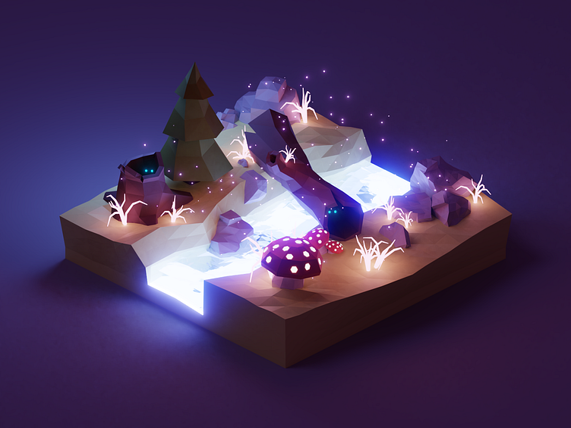

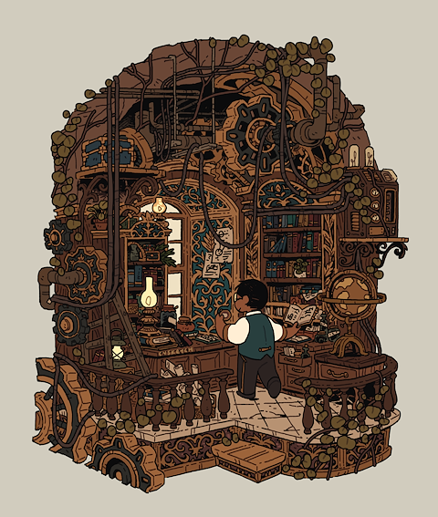

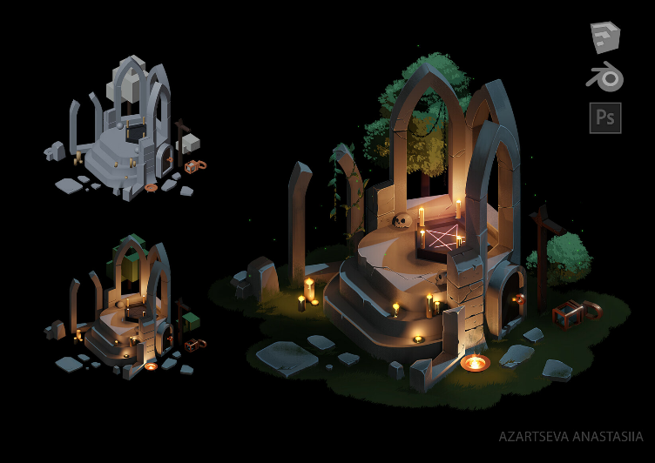

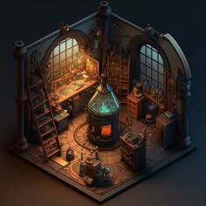

**Game World Fiction**

*The game has diary pages scattered all over the place. Some of them tell some story, and some may contain miscellaneous text, like a recipe for a chocolate cake.*

**Monetization**

*There is no immediate plan to make money with this game, since I am making it for my portfolio. However, I will publish it on itch.io and make a kickstarter page for it in case there are people who would fund the game’s development for it to become a full product.*

**Platform(s), Technology, and Scope (brief)**

*Game is made on Unity 3D for PC platform only. I am making it alone during the span of 2 months. First playable experience should be available in 2 weeks from the start of the development, and then expanded upon with more puzzle types and rooms for the rest of project’s development time.*

***First playable demo*** *will include minimal graphics, 4 rooms and 2 puzzles.*

***Complete game*** *will include 3 areas including hub area made out of 4-6 rooms each. Every area has its own puzzle type, as well as meta puzzles.*

# Detailed Game Systems Design

**Core Loops**

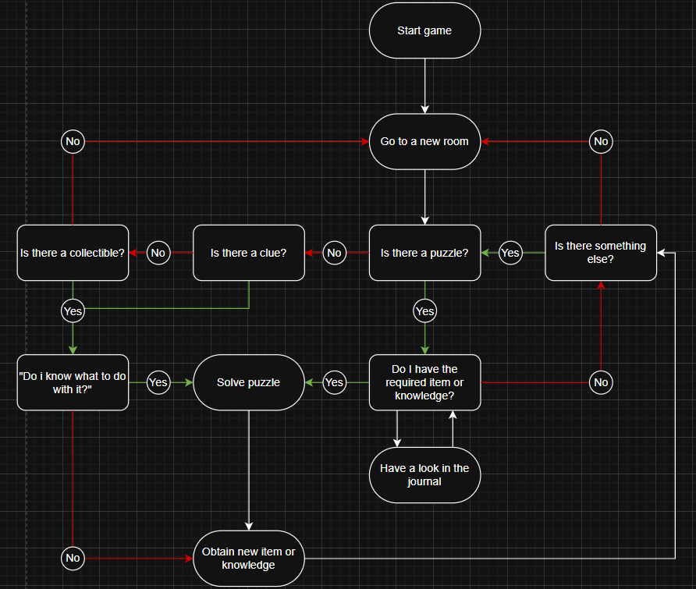

*Core gameplay loop that consists of the player exploring around the game’s world, finding puzzles and discovering clues.*

*The expected result of this is that the player will not get stuck on a puzzle they don’t know the obvious solution for, and will continue searching for that solution, to eventually find it, or find something else to worry about before returning to the puzzle they got stuck on.*

**Objectives and Progression**

*Player starts in the forest, where they get taught how the game works by showing signs with controls written on them (not literally written in words).*

*When the player gets the basics, they can progress further in the mansion, where they end up in the hub area, heading from south. It is only possible progress in one cardinal direction, being north, since east is blocked, and the door on the west side is locked.*

*From the northern wing of the mansion, the player can reach the east side by climbing the outside ladder to the roof. After getting through the top floor, the player will find a key, which unlocks the final west wing.*

*In the west wing, the player will be able to get a clue for a solution of the final puzzle located back I the north wing, after solving which, the game is won.*

**Game Systems**

*There will be 6 systems for the player to interact with:*

1. *Map + compass (UI element)*
2. *Inventory*
3. *Journal*
4. *Traversal of the game world*
5. *Picking up items / journal pages*
6. *Puzzles*

**Interactivity**

*How are different kinds of interactivity used? (Action/Feedback, ST Cog, LT Cog, Emotional, Social, Cultural)  What is the player doing moment-by-moment? How does the player move through the world? How does  physics/combat/etc. work? A clear, professional-looking sketch of the primary game UX is helpful.*